UsersRoles Application

User Guide

Table of Contents

1. Introduction: 3

2. Requirements: 3

3. Configuration: 3

3.1 Database bak file: 3

3.2 Edit Appsettings.json File: 3

4. Running the application: 3

5. Features: 3

5.1 Login Page: 3

5.2 Registration form: 4

5.3 User View: 5

5.4 Admin View: 5

# Introduction:

UsersRoles application is an application that makes authentication and authorization for users using cookies authentication and claims in .net core framework.

**For admin user use:**

**Username: admin**

**Pass: 123**

# Requirements:

* .Net core version 3.1.
* Sql server instance 16.
* Visual studio 2019 or any other IDE that supports the mentioned .net core version

# Configuration:

## Database bak file:

Start by restoring the bak file in the solution to your database.

## Edit Appsettings.json File:

After opening the application in your favorite IDE, go to **appsettings.json** file and make sure to update the **DefaultConnection** field to suits your database configurations.

# Running the application:

In case of using visual studio 2019 the application can run directly by pressing F5 to run in debugging mode or (ctrl + F5) to run without debugging mode. Also as a second way open a new Cmd and change directory to the location of the application **Ex: Cd D:\WorkBanch\UsersRoles**. And then run **dotnet run** command in the Cmd.

# Features:

## Login Page:

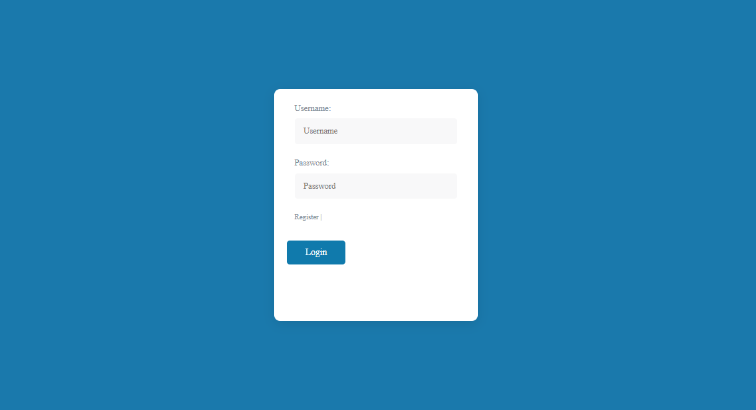

By running the application, the default page that open’s will be the login page, where the registered users can sign in and be redirected according to their roles. If the user isn’t registered yet, he can go to the registration page by clicking on **register** to create new account

## Registration form:

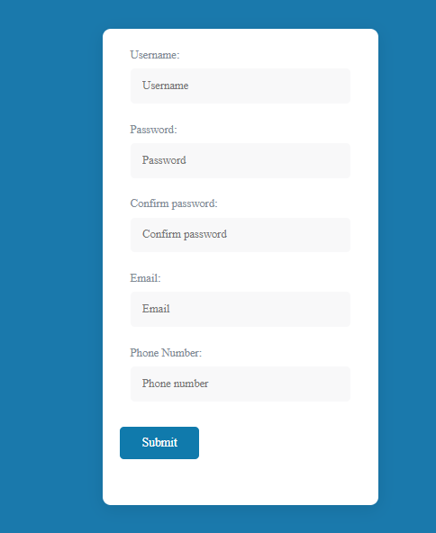

In the registration from the new user fill his data, and on submit the data will be saved in database and will be redirected to login page. The user must wait until his role is updated from the admin user in order to be able to login. Once the role is update, then the user will be able to login.

## User View:

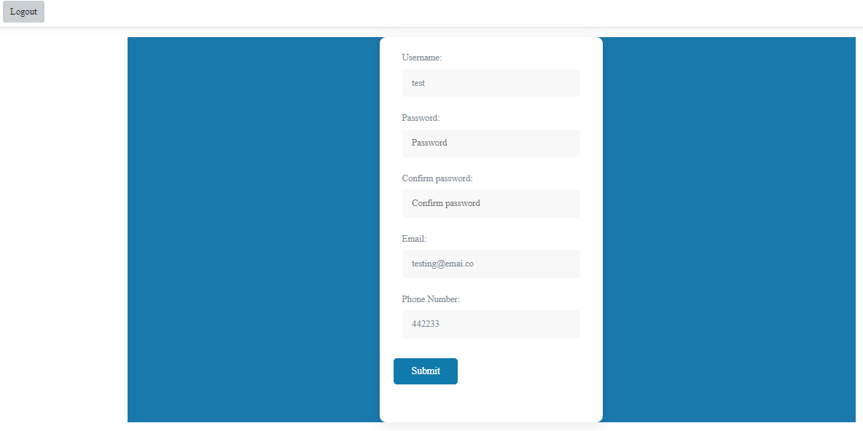

In this role view, the logged in user can see his data make the necessary updates.

## Admin View:

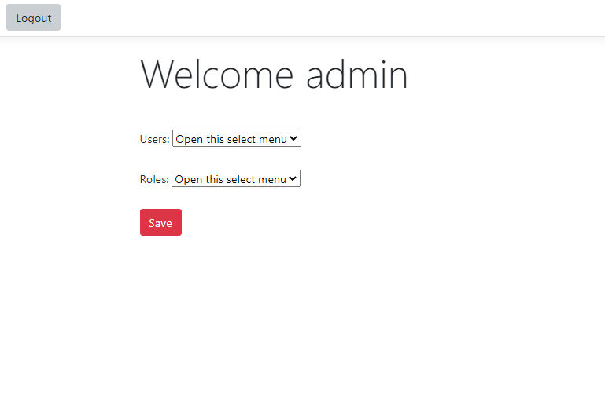

In the admin role view, the admin can assign the role for the user, by selecting the user from users drop down and his role in the roles drop down and then click the save button. After updating the user role in the database an alert will be shown on success.